QUEST EMPLOYMENT 2018 GENDER PAY STATEMENT
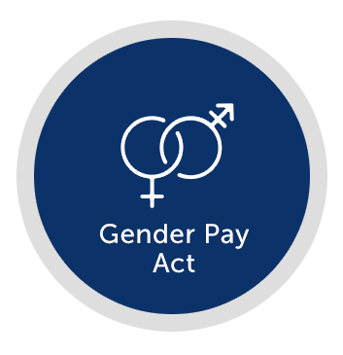

INTRODUCTION TO GENDER PAY REPORTING
Quest Employment is a supplier of flexible workers to clients predominantly within the distribution, warehouse and food production sectors. We also have a small proportion of workers in the commercial sector, covering call centre and general administration work, and in the technical sector.
When we say , we mean it. We are proud to be an employer that supports a very diverse workforce. We are committed to creating an inclusive work environment where the whole workforce feels welcomed, valued for their contributions and fully engaged with our business. At Quest, we are dedicated to the belief that individuals should be compensated competitively and fairly based on their role and skills. Opportunities within our business are open to all people equally, and we encourage career progression in all of our workers.
The gender pay gap data within this report looks at two distinct types of employees; firstly, our flexible workforce, working at our client’s premises fulfilling our client’s staffing needs, secondly, our permanent employees, working in our branch network and support staff working centrally.

Lynn Banks
Finance Director

UNDERSTANDING OUR GENDER PAY REPORT
We are required to publish figures detailing the differences in pay between male and female workers across our entire workforce regardless of job role.

Gender pay reporting is different to equal pay
Equal pay deals with the pay differences between men and women who carry out the same jobs, similar jobs or work of equal value.
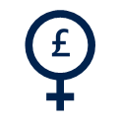
The gender pay gap shows the difference in the average pay between all men and women in a workforce.

What are the calculations?
We are required to publish six calculations showing:
- average gender pay gap as a mean average (the difference between the average of men’s and women’s pay)
- average gender pay gap as a median average (the difference between the midpoints in the ranges of men’s and women’s pay)
- average bonus gender pay gap as a mean average (the difference between the average of men’s and women’s bonus)
- average bonus gender pay gap as a median average (the difference between the midpoints in the ranges of men’s and women’s bonus)
- proportion of males receiving a bonus payment and proportion of females receiving a bonus payment
- proportion of males and females when divided into four groups ordered from lowest to highest pay.

OUR RESULTS FOR 2018
As we have two distinct types of workers at Quest, we feel it is important to publish results for the sectors separately, so this report will set out figures for the flexible workforce and permanent workforce separately.

FLEXIBLE WORKFORCE
At Quest, the majority of our flexible workforce are blue collar workers, paid at National Minimum wage/Living wage or just above. Workers rates of pay are set for the job role that they do, so workers are paid the same, regardless of gender.
We do have a higher proportion of male workers at 59% and this is due to the type of work we specialise in attracting more male applicants than female.

Mean Gender Pay Gap  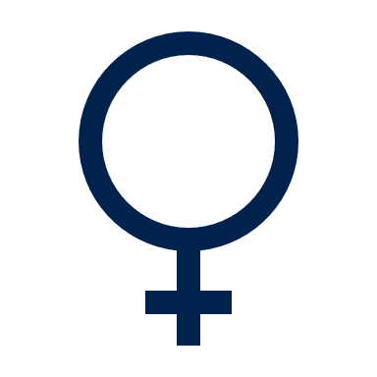  -0.76%  £  £  The difference between the average of men’s and women’s pay |  | Median Gender Pay Gap  0.00%  The difference between the midpoints in the ranges of men’s and women’s pay

Our mean gender pay gap for our flexible employees is under 1% in favour of women. We would expect our mean gender pay gap to be small as our workers are all paid equally, with rates set for the job role and the majority of the workforce are paid at National Minimum wage or just above.

There is no difference at all in our Median gender pay gap.

We had no flexible employees receiving a bonus in the snapshot week.

Quartile Pay Bands

These quartiles represent the pay rates from the lowest to the highest for our flexible workforce split into four equal sized groups, with percentage of men and women in each quartile.
As detailed previously, men make up 59% of the flexible workforce at Quest, so there are more men than women in all of our pay quartiles.
The figures are very similar in each quartile, and show an even distribution of men and women, when taking into consideration that 59% of the workforce are men.

Lower Quartile | Lower Middle Quartile | Upper Middle Quartile | Upper Quartile

PERMANENT EMPLOYEES
At Quest, women make up 59% of our permanent workforce, with 46% working part time hours. Our senior staff are all full time, with 20% of women being in managerial positions, and 34% of men.

Mean Gender Pay Gap  20.77%  £  £  The difference between the average of men’s and women’s pay |  | Median Gender Pay Gap  14.46%  The difference between the midpoints in the ranges of men’s and women’s pay

Although both our mean and median pay gaps seem high, the obvious reason is because of the high percentage of part time women employed by Quest. Part time workers have a much lower average pay, as they are only paid for working a proportion of the hours.
Our Head Office based support staff also work standard office hours, rather than the extended branch hours, so the 90% of Head Office staff would also reduce the average pay for women, due to the reduced hours.
Quest Employment are confident that men and women are paid equally for doing equivalent jobs across our business, and are proud to be an employer that looks to accommodate flexible working patterns for people that require them.

Employees receiving a bonus
Our bonus and reward schemes are multi-faceted. They vary between performance related bonuses for sales staff and profit related bonuses for branch and support staff. Different job roles may have different bonus schemes, but bonus packages are the same for all employees doing the same role, so there is actually no gender gap at all in the bonus schemes we offer.
93.62%
87.50%

We have a higher percentage of women earning bonus than men, but this does not reflect in the mean or median percentages, because of the number of part time women employees, whose bonus is paid pro rata on the hours they work.

Mean Gender Bonus Gap  55.12%  £  £  The difference between the average of men’s and women’s bonus |  | Median Gender Bonus Gap  46.88%  The difference between the midpoints in the ranges of men’s and women’s bonus

Quartile Pay Bands
These quartiles represent the pay rates from the lowest to the highest for our permanent employees split into four equal sized groups, with percentage of men and women in each quartile.
As detailed previously, women make up 59% of the permanent workforce at Quest, so there are more women than men in all of our pay quartiles.
In quartiles 2, 3, and 4, which represent the middle to upper paid roles within Quest, the figures are close to the gender split. The percentage is slightly lower for women in the upper middle quartile band, due to there being a higher number of Branch Managers at this time are men.
In the lower quartile band, unsurprisingly the percentage is much higher (73.68%) of women. This is again due to the number of part time working women we employ, where the pay would be lower, due to the reduced number of hours worked.

Lower Quartile | Lower Middle Quartile | Upper Middle Quartile | Upper Quartile

